User manual tariff engine
Jamie Woodford
29-2-2016
Version 1.0

Version 2.1 (7-7-2022)

Introduction

Transsmart provides the possibility to predict transport costs based on the contract(s) a customer has with one or more carriers. As the amount of carriers which have a connection with Transsmart has grown over the years so too have the various sorts of contracts customers have with these carriers. To facilitate the prediction of the transport costs in an efficient way this tariff engine has been developed. This user manual is intended to explain to customers how this engine works and how customers can set-up and maintain the rates themselves.

2. Process description

In the following scheme it is visualized how the rate calculation process is set-up:
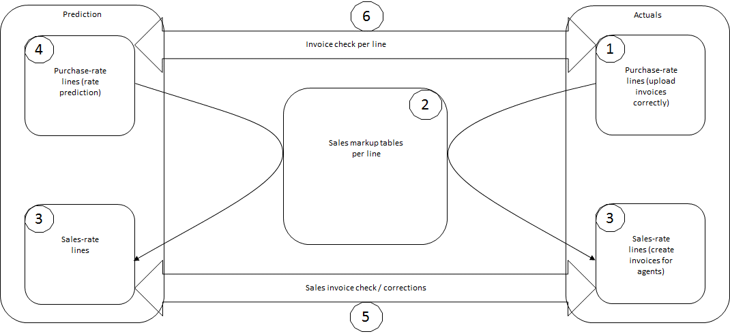
Figure 1. Schematic overview of rate calculation process Transsmart
During the rate calculation the transport costs are calculated or predicted.
Furthermore analysis is possible between the predicted costs and the actual costs. Since the costs for shipping and surcharges are stated separately it is possible to analyze a complete breakdown of the rate calculation.

Basic configuration

For the rate calculation the following tables can be of relevance:
Previous table name (<2022) | Table name
Client-carrier | Client Carriers
Zone Lookup | Zones
Weight Determination Lookup | Buy Weights
Sales Weight Determination Lookup | Sell Weights
Tariff Determination [DEV] | Buy Rates
Sales Tariff Determination [DEV] | Sell Rates
Sales Margins [DEV] | Sell Margins

Please note that of the above tables only the Buy Rates, Sell Rates and Sell Margins can be configured by customers; the other tables can only be configured by a Transsmart employee. The rest of this manual will focus on the Buy Rates table. However, to further the understanding of the system all tables will be explained below:

Client Carriers
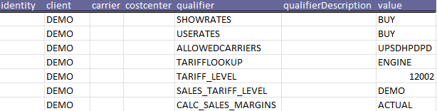
Figure 2. possible parameters in Client Carrier table

In this table the customer and carrier parameters are defined. For rate calculation the following parameters are relevant:
SHOWRATES: this parameter defines which rates are visible in the online platform and in the API. The following settings are available:
- BUY: only purchase rates are shown
- SELL: only sales rates are shown
- BUYSELL: both purchase and sales rates are shown
USERATES: through this parameter either purchase (BUY) or sales (SELL) rates are used in case of CHEAPEST logic (always chose the cheapest transport option). For this parameter one of both options needs to be chosen.
TARIFFLOOKUP: to use the tariff engine this parameter should always be set to ENGINE. It is also possible to set NONE (no rates are calculated) or CARRIER (rates are obtained from the carrier if available).
TARIFF_LEVEL: this parameter enables you to determine on which level in our hierarchy the purchase (BUY) rates are calculated. This can be used when customers use a sub-accounts set-up to set whether rates are calculated on customer_id level, group_id level or organisation_id level.
SALES_TARIFF_LEVEL: this parameter has the same functionalities as the TARIFF_LEVEL but then for the sales rates.
CALC_SALES_MARGINS: if this parameter is set to ACTUAL recalculation of rates based on the purchase invoices is enabled.

Zones
The zones table determines to which delivery zone a booking is made. This can be set on a number of levels: generic on carrier level, on customer level, on collection country level, on serviceleveltime level, on servicelevelother level, on costcenter level or on a combination of these. The resultant zone is used in the rate calculation as different zones can have different rates.

Buy Weights
The Buy Weights table is used to calculate the weight which needs to be used during the rate calculation. As consignors can have both voluminous goods and heavy goods it is not always the gross weight which needs to be used in the rate calculation. By setting the factor for volume and / or load meters the system will determine which of the 3 weights (gross weight, volume weight and load meter weight) is the highest and this will be used in the rate calculation. As there are also rate structures where there are collo rates for example this table does not necessarily have an impact on the rate calculation.
The weight determination can be set on various levels: generic on carrier level, on customer level, on collection country level, on serviceleveltime level, on servicelevelother level, on costcenter level, on packagetype level or on a combination of these.

Sell Weights
This table has the same functionality as the Buy Weights table but then for the sales rates and / or margins.

Buy Rates
The basic assumption of the tariff engine is that the entire set-up is done in one table, the Buy Rates. During calculation all relevant lines are found and added up to determine the rate (whereas before only one line could be found, resulting in far more tariff lines). This means that lines applicable on collo, package or shipment level can be relevant.
First an explanation is given of the various columns in this table and afterwards some examples are described:

# | Element | Mandatory | Description
1 | Identity | N | This field contains the unique database ID of the record. If you download existing records, it will be filled. If you wish to upload and overwrite existing records, this field needs to remain filled. If you wish to add new lines, make sure this field is empty.
2 | customerId | N | In this column all values of the customer hierarchy can be used: customer_id, group_id and organisation_id
3 | costcenter | N | If a cost center has different rates this can be set-up by filling this column
4 | level | Y | Rates can be set on various levels: COLLO, PACKAGE and SHIPMENT. Based on this value the rates are calculated differently. See below for an explanation on the differences of each level
5 | carrier | Y | The carrier needs to specified here
6 | serviceLevelTime | N | The serviceleveltime can be specified here if different rates are applicable for different serviceleveltime values
7 | serviceLevelOther | N | The servicelevelother can be specified here if different rates are applicable for different servicelevelother values
8 | packageType | N | The package type can be specified here if different rates are applicable for different package types
9 | carrierAccountno | N | The carrier account number can be specified here if different rates are applicable for different account number
10 | inbound | N | It can be specified here if rates are for inbound shipments. Default this is set to ‘0’ meaning an outbound shipment
11 | zone | N | The zone can be specified here if different rates are applicable for different zones
12 | minTotalWeight | N | The minimum total weight in KG of the specified level (#3) is stated here. It can be specified until 3 digits after the decimal point
13 | maxTotalWeight | N | The maximum total weight in KG of the specified level (#3) is stated here. It can be specified until 3 digits after the decimal point
14 | minLength | N | The minimum length in CM of each collo is specified here. In case of multi colli shipments each collo is checked separately. It can be specified until 3 digits after the decimal point
15 | maxLength | N | The maximum length in CM of each collo is specified here. In case of multi colli shipments each collo is checked separately. It can be specified until 3 digits after the decimal point
16 | minWidth | N | The minimum width in CM of each collo is specified here. In case of multi colli shipments each collo is checked separately. It can be specified until 3 digits after the decimal point
17 | maxWidth | N | The maximum width in CM of each collo is specified here. In case of multi colli shipments each collo is checked separately. It can be specified until 3 digits after the decimal point
18 | minHeight | N | The minimum height in CM of each collo is specified here. In case of multi colli shipments each collo is checked separately. It can be specified until 3 digits after the decimal point
19 | maxHeight | N | The maximum height of each collo in CM is specified here. In case of multi colli shipments each collo is checked separately. It can be specified until 3 digits after the decimal point
20 | minConveyDimension | N | The minimum dimension of the level (collo, package, shipment) in CM is specified here. This is calculated by adding up length + 2*width + 2*height. It can be specified until 3 digits after the decimal point
21 | maxConveyDimension | N | The maximum dimension of the level (collo, package, shipment) in CM is specified here. This is calculated by adding up length + 2*width + 2*height. It can be specified until 3 digits after the decimal point
22 | minLoadmeter | N | The minimum load meter of the shipment, package or collo is specified here. It can be specified until 3 digits after the decimal point
23 | maxLoadmeter | N | The maximum load meter of the shipment, package or collo is specified here. It can be specified until 3 digits after the decimal point
24 | minVolume | N | The minimum volume of the level (collo, package, shipment) in CM³ is specified here. In case of multi colli shipments each collo is checked separately. It can be specified until 3 digits after the decimal point
25 | maxVolume | N | The maximum volume of the level (collo, package, shipment) in CM³ is specified here. In case of multi colli shipments each collo is checked separately. It can be specified until 3 digits after the decimal point
26 | minValue | N | The minimum commercial value of the shipment, package or collo is specified here. It can be specified until 3 digits after the decimal point
27 | maxValue | N | The maximum commercial value of the shipment, package or collo is specified here. It can be specified until 3 digits after the decimal point
28 | colloQuantityFrom | N | The minimum number of colli can be specified here
29 | colloQuantityTo | N | The maximum number of colli can be specified here
30 | calcType | Y | The method to be used to calculate the rate is set here. Please see below under ‘Calculation Type’ for additional information
31 | queryType | N | The method to be used to calculate the rate is set here. Please see below under ‘Query Type’ for additional information
32 | tariffValue | Y | The actual rate is set here. This can be a flat rate, a percentage or a KG rate. It can be specified until 4 digits after the decimal point
33 | currency | Y | The currency which is used is set here
34 | chargeGroup | N | The charge group to be used is set here. Please see below under ‘Charge Group’ for additional information
35 | chargeType | N | The charge type to be used is set here. Please see below under ‘Charge Type for additional information
36 | boundaryType | N | In this element additional restrictions can be specified which need to be taken into account such as COLLOWEIGHT, PALLETWEIGHT or LOADMETER
37 | boundaryMin | N | If a restriction is specified in element #25 then this parameter sets the minimum value for this. It can be specified until 3 digits after the decimal point
38 | boundaryMax | N | If a restriction is specified in element #25 then this parameter sets the maximum value for this. It can be specified until 3 digits after the decimal point
39 | validFrom | Y | The start date of when the rate is valid is set here
40 | validUntil | Y | The end date of when the rate is valid is set here

Calculation Type
# | Calculation Type | Level | Description
1 | BASE | Shipment  Collo  Package | With this type a fixed price for that specific line is set. It can be specified until 4 digits after the decimal point
2 | PIECE | Shipment  Collo  Package | Through this type a rate per collo is set. The formula to be used is relevant amount*tariffValue. It can be specified until 4 digits after the decimal point
3 | KG | Shipment  Collo  Package | This enables a rate per KG. Based on the Buy Weights table either the calculated weight or the gross weight (whichever is the highest) will be used and, if set, a rounding factor will be used.  It is important to set the queryType to STAFFEL. This calculation type will likely always lead to multiple rate results as a scale is generally applied for various weights and on top of that a KG rate is added: if a shipment weighs 73,26 there will be a result for the BASE price scale 70.01 to 9999.00 kg and a result for the KG – STAFFEL line of 70.01 to 9999.00 kg. The formula to be used is tariffValue (euro per kg)*amount kg. It can be specified until 4 digits after the decimal point
4 | PERCENT_VALUE | Shipment | In this way a percentage is calculated in relation to the commercial value of the shipment. The method to set a percentage is 0.01 equals 1%. The percentage can be specified until 3 digits after the decimal point
5 | PERCENT_SERVICE | Shipment | This calculation type uses a similar functionality to PERCENT_VALUE but then a percentage of the purchase value is added. An example of this type is a fuel surcharge and / or an oversize surcharge. The percentage can be specified until 3 digits after the decimal point
6 | LOADMETER | Shipment  Package  Collo | In this way the calculated load meters are used to determine the transport costs.
7 | VOLUME | Shipment  Package  Collo | In this way the calculated volume are used to determine the transport costs.
8 | MINIMUM | Shipment  Collo  Package | With this type a minimum result can be set combined with the specified chargeGroup.
9 | MAXIMUM | Shipment  Collo  Package | With this type a maximum result can be set combined with the specified chargeGroup.
10 | MIN_PRICE_PIECE | Shipment | This calculation type can be used to indicate a minimum price for an entire shipment.

Query Type
The parameter Query Type is needed to calculate certain exceptions. In general this parameter is set to SINGLE by default. There are two exceptions for this parameter:
- OR
- STAFFEL
OR is used for certain surcharges to determine for a collo or shipment whether one of the following limitations is exceeded:
- Total weight
- Total length
- Total width
- Total height
- Total convey_dimension
If at least one of these limitations is exceeded a surcharge will be calculated. An example of this is the conveyor surcharge of PostNL.
STAFFEL is used when a KG (kilogram) contract is applicable with one or more scale rate structures. This parameter enables the possibility to add up multiple scales. An example of this is the DHL Express rate structure with a basic rate (BASE price) up to 10 KG and furthermore various weight scales (10-30kg, 30-70kg, 70-200kg & 200-2500kg). As the parameter STAFFEL is used both the BASE price and the STAFFEL price will be added up to result in the final price.

Charge Group
Two charge groups are used: SHIPPING and SURCHARGE. Shipping is used for the basic transport costs and SURCHARGE is used for all surcharges such as fuel, customs and oversize surcharges. Through the charge types these can be defined further.

Charge Type
Next to the Charge Group a Charge Type is also specified for each line in the tariff engine. The Charge Type determines the specific transport cost component. These components can be maintained in the Generics table.
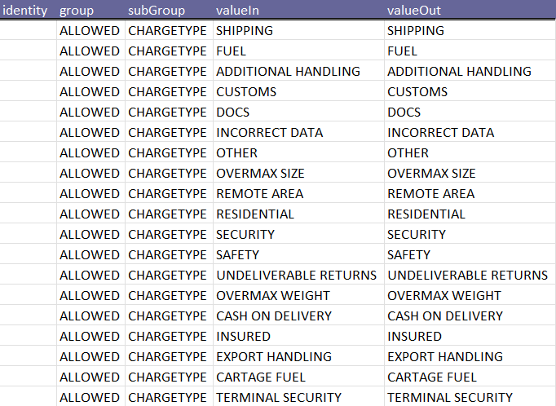
Figure 3. possible parameters for Charge Type

4. Examples

Below some example files are available, including an explanation of why the rates have been set-up in this particular way:

DPD
In this rate sheet the following methods are used to calculate the transport costs:
- The level (column D) is set to COLLO meaning that the rate will be calculated for each individual parcel or pallet.
- The serviceLevelTime (column F) is not set for all lines, meaning that the value in line 4 for example will apply to all shipments within the further parameters.
- The maximum weight (column M) is set to 31.50 KG, therefore a booking with any collo heavier than this will result in an error message: “shipping costs empty”
- Not all costs are shipping costs. For line 4 it is set in column AH and AI that this is a remote zone surcharges. This will result in additional costs for all shipments to zone NL_02, these will be specified separately in any reports.

Fedex (FED)
In this rate sheet the following methods are used to calculate the transport costs:
- In line 2 the fuel surcharge is specified as stated in columns AH and AI. This is generally done on SHIPMENT level (column D).
- Certain lines are only applicable for specific package types (column H).
- The rate structure is based on weight and increases by 0,5 KG for each line. As of line 26 there is no more weight step, all shipments then have the same basic price.
- As of line 27 there is a scale rate structure, as can be determined from column AD and AE. Based on the minimum and maximum weight in columns L and M a separate rate can be set per KG which will be added to the basic price of line 26.
- If the weight of the shipment applies to multiple scale sections then ALL applicable lines will be included in the transport cost calculation.

PostNL (PNL)
In this rate sheet the following methods are used to calculate the transport costs:
- For certain services additional costs are applicable. These might be for the entire shipment while the rate structure is per collo. An example of this is the rates in line 3, 4 and 5. The basic rate is per collo (COLLO is specified in column D on line 3) but on SHIPMENT level additional costs are applicable as is specified in line 4. Furthermore, if a specific servicelevelother (AVOND) is used then again additional costs are applicable.
- As is shown in lines 83 and 84 a surcharge is applicable for oversize packages. As the surcharge can be for either length or width the “OR” option is used in column AE. This combined with a rate on COLLO level and a calculation type per PIECE (column AD) means that this surcharge can be applicable for each package.

E. van Wijk (EVW)
In this rate sheet the following methods are used to calculate the transport costs:
- As Van Wijk is a carrier which mainly focusses on pallet transport their rates are based on loadmeters. The system will calculate the amount of loadmeters for the specific booking and then find the appropriate lie in the tariff sheet. This method can be used by setting the boundary type in column AJ (LOADMETER) and then stating the lower and upper margins for each line (column AK and AL).
- As the rates are on SHIPMENT level the total loadmeters for all packages in the booking will be used to determine the applicable line in the tariff sheet.

UPS
In this rate sheet the following methods are used to calculate the transport costs:
- Certain carriers have different rates for single coli and multi colli shipments. In this example the rate structure is based on the shipment weight (as can be determined from columns D, L and M) and next to this it is specified in columns AB and AC whether it is a single or multi colli rate.
- When a booking is made the system will determine based on the number of colli which line(s) is (are) applicable.
- If a multi colli booking is made a weight scale is also applicable, in lines 54 and 55 this is specified.

GLS
In this rate sheet the following methods are used to calculate the transport costs:
- GLS can also have different rates for single coli and multi colli shipments. Contrary to UPS however this is calculated per collo and not on shipment level.
- In this example the rate structure is based on the amount of colli (as can be determined from column D, AB and AC) in combination with the collo weight (columns L and M).
- Even though the tariff engine set-up has similarities with that of UPS the rate structure of this carrier is entirely different.

