JasperReports manual
Last updated 16-6-2022

0. Introduction
In this document the basic functions of JasperReports are explained. It also contains information about the reports.

Table of contents

Chapter Page
0. Introduction 1
1. Get started 2
2. How To’s 3-5
3. Reports 6-8
4. FAQ’s 9
5. Mapping of old versus new JasperReports 10

1. Get started
How to access?
Go to https://reports.transsmart.com/ and log in with the user name and password provided by a nShift employee.

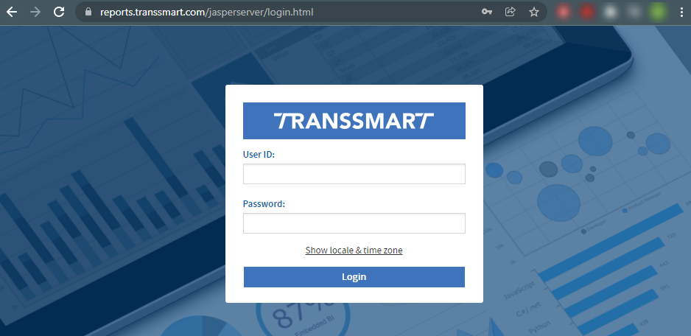

Basic functions:

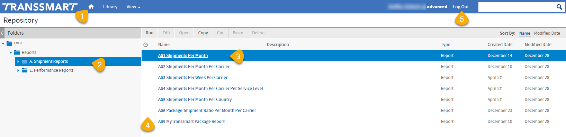
- Home page
- Click on a group to see the reports (see chapter ‘3. Reports’)
- Click on a report to run and download it (see chapter ‘2.1 How to: download a report’)
- Right mouse click to create/edit a schedule (see chapter ‘2.2 How to: schedule a report’)
- Log Out

2. How To’s

2.1 How to: download a report
1. Run the report by clicking on it in the overview page.
2. Fill in the desired options. These can be different per report but most common ones are:
- Insert Date From ( = booking date)
- Insert Date To ( = booking date)
- Carrier
- Costcenter
- Service Level
3. Click ‘Apply’.
4. Then click the download icon and choose the format in which you want to download the report.
- “XLSX” is most probably the most used option; this is the standard Excel format.
- “PDF”
- “CSV”
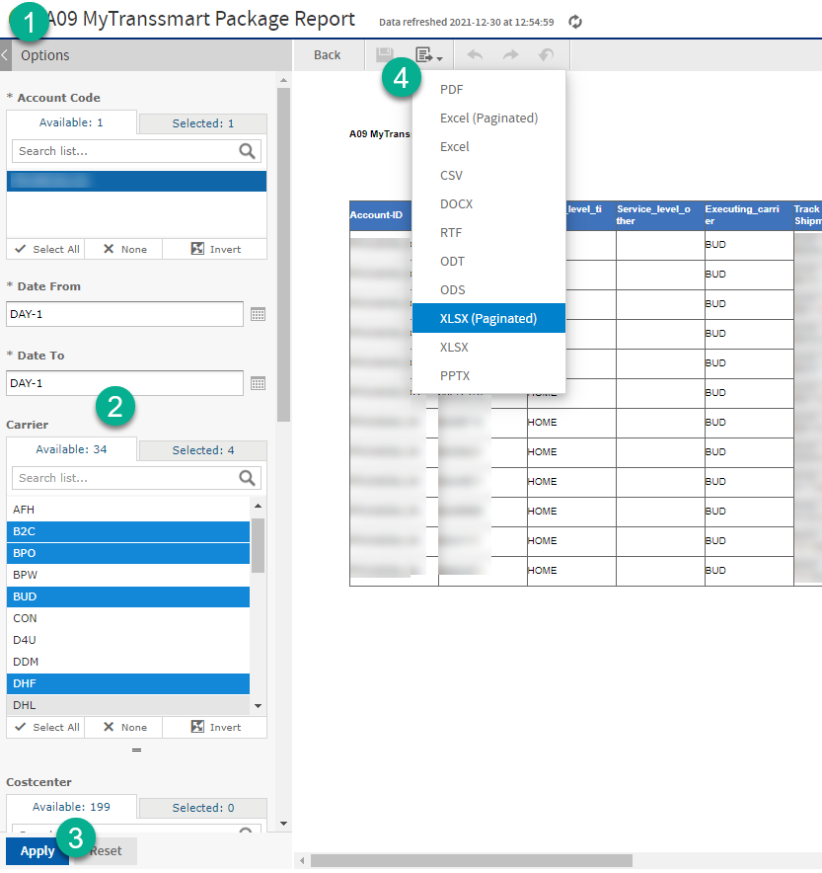

2.2 How to: schedule a report
1. In the main screen with reports, in the first column with the clock, click with the right mouse button.
2. Click ’Schedule’.
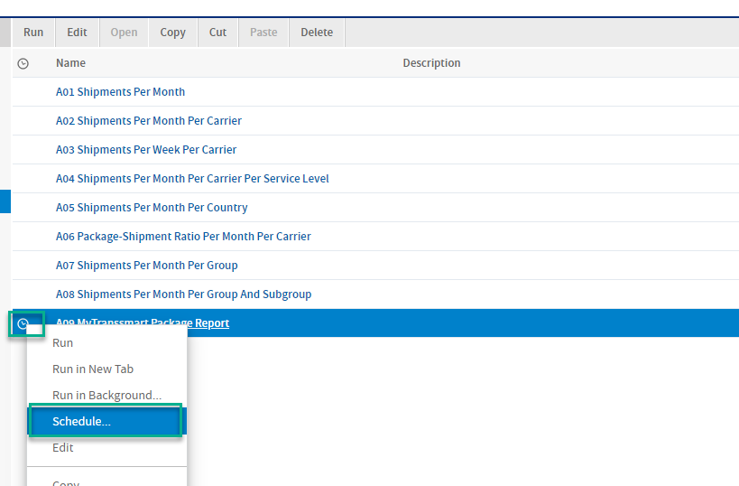
3. In the next screen, choose options ‘Create Schedule’.
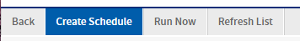
4. Fill in the following data:
A. Desired schedule:
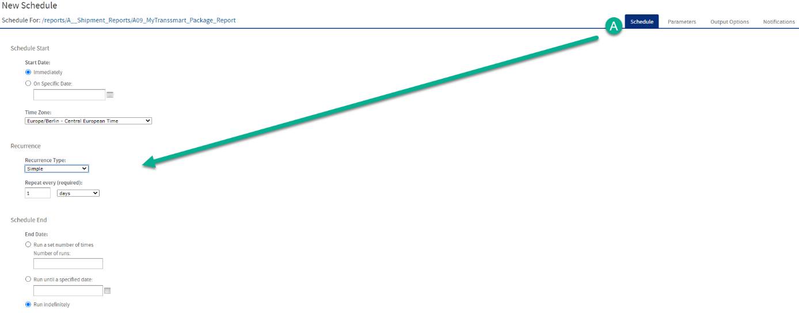

B. Desired parameter options/filters:
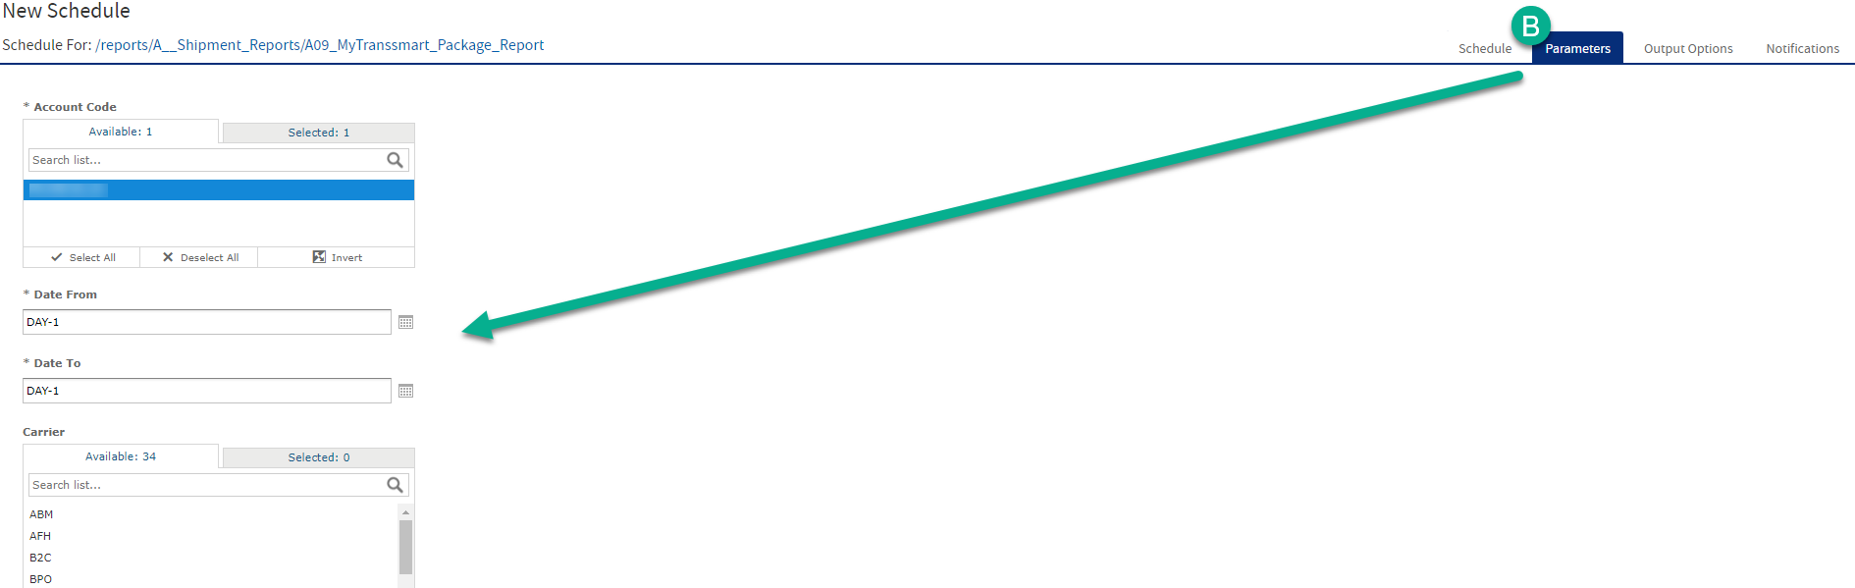
Tip: ‘Date From’ / ‘Date To’: when filling in “MONTH-1” in both fields, it will use the start and end date of the previous month, which is very handy if you want to receive a monthly report on the first day of the new month.

C. Desired format. If you want to receive the report via a FTP-server, you can set it up in here. If you want to receive an email with attachment, go to the next “D - Notifications”:
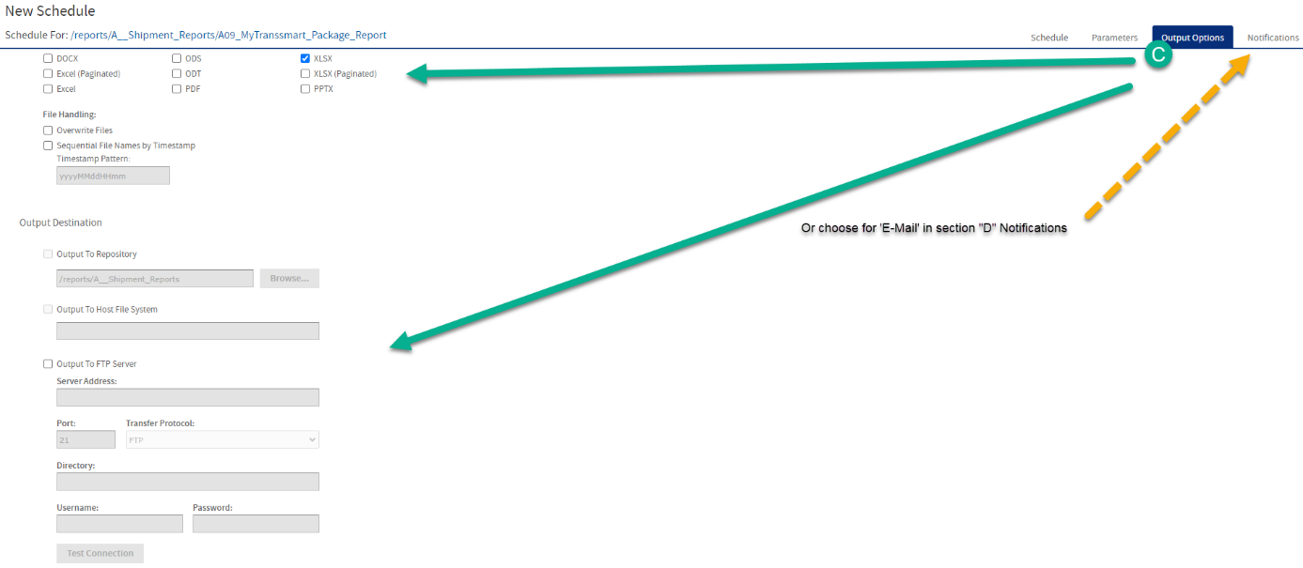
- Overwrite Files: in case you push to FTP, when turning this setting on, it will overwrite the file if it already exists with the same name.
- Sequential File Names by Timestamp: when turning on, this will make the file names unique (both as email attachment as in pushing to FTP) by putting a unique timestamp behind it.
D. Desired email options:

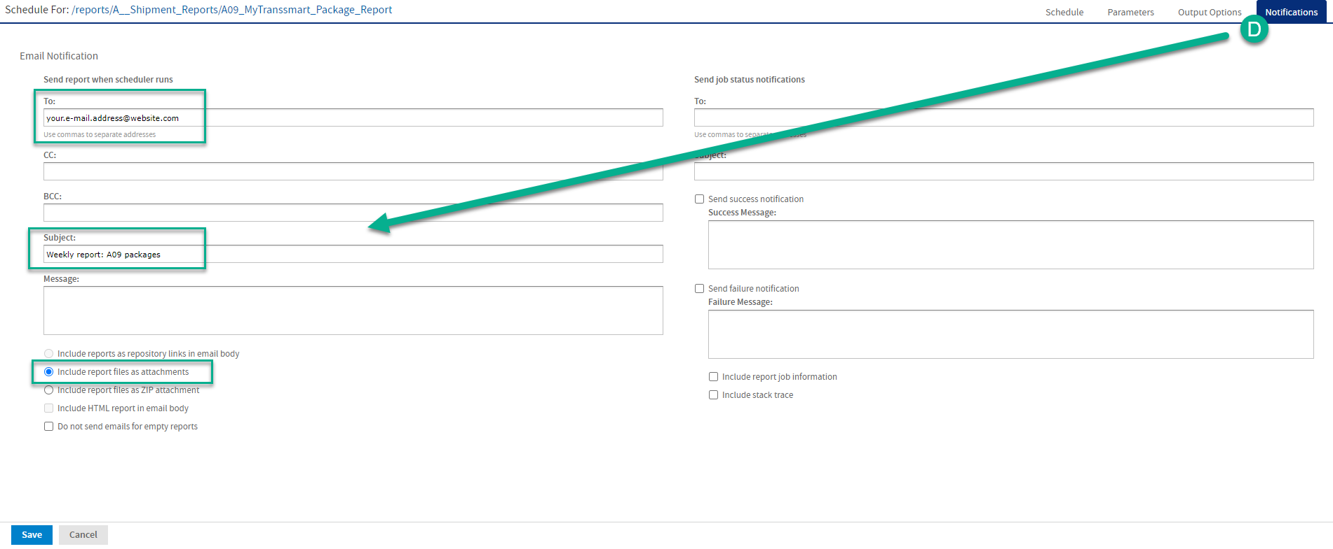

After filling in all fields, save the schedule and give it a job name.
The email will be sent by noreply@transsmart.com.

3. Reports
A. Shipment Reports
A01 Shipments Per Month | Shows counter of shipments per month.  - Filters: First Month, Last Month  - Statuses: non specified
A02 Shipments Per Month Per Carrier | Shows counter of shipments per month per carrier with totals per carrier and totals per month.  - Filters: First Month, Last Month, Carriers, Costcenter  - Statuses: non specified
A03 Shipments Per Week Per Carrier | Shows counter of shipments per week per carrier with totals per carrier and totals per week.  - Filters: First Week, Last Week, Carriers, Costcenter  - Statuses: non specified
A04 Shipments Per Month Per Carrier Per Service Level | Shows counter of shipments per month per carrier per service level with totals per month.  - Filters: First Month, Last Month, Carriers, Costcenter  - Statuses: non specified
A05 Shipments Per Month Per Country | Shows counter of shipments per month per carrier per country with totals per month.  - Filters: First Month, Last Month, Carriers, Costcenter, Country  - Statuses: non specified
A06 Package-Shipment Ratio Per Month Per Carrier | Shows ratio of the number of package lines per shipment per month per carrier.  - Filters: First Month, Last Month, Carriers, Costcenter  - Statuses: non specified
A07 Shipments Per Month Per Group | Shows counter of shipments per month per account with totals per account and totals per month.  - Filters: First Month, Last Month  - Statuses: non specified
A08 Shipments Per Month Per Group And Subgroup | Shows counter of shipments per month per subaccount with totals per subaccount and totals per month.  Only shows accounts which have subaccounts.  - Filters: First Month, Last Month  - Statuses: non specified
A09 MyTranssmart Package Report | Shows shipment details split out per package. Report has same format as the Excel download that can be done in MyTranssmart dashboard in menu Reporting with ‘Report type’ = “Collo”.  - Filters: Account Code, Date From, Date To, Carrier, Costcenter, Service Level Time, Service Level Other, Country, Status  - Statuses: non specified

E. Performance Reports
E01 Shipments Booked | Shows booked shipment details on package level in a specific time range with several filter options.  - Filters: Date From, Date To, Account Code, Carrier, Carrier Account Number, Service Level Time, Service Level Other, Country  - Statuses: BOOK, LABL, MANI, TRNS, ACCEP, DONE, APOD, ONHOLD
E02 Shipments Booked All | Shows booked shipment details on shipment level in a specific time range.  - Filters: Date From, Date To  - Statuses: all, except DEL, ERR, NONE
E03 Shipment Exceptions | Shows booked shipment details in a specific time range for delayed shipments and shipments with an exception status.  - Filters: Date From, Date To, Account Code, Carrier, Carrier Account Number, Service Level Time, Service Level Other, Country  - Statuses: NEW, BOOK, LABL, MANI, TRNS, ACCEP, APOD, DELAY, ONHOLD, REFU
E04 Shipment Overview | Shows booked shipment details in a specific time range per weight range per account including Sell Price.  - Filters: Date From, Date To, Account Code, Carrier, Carrier Account Number, Service Level Time, Service Level Other, Country  - Statuses: BOOK, LABL, MANI, TRNS, ACCEP, DONE, APOD
E06 Shipment Performance | Performance overview that shows booked shipment details in a specific time range with times, dates and statuses.  - Filters: Date From, Date To, Account Code, Carrier, Carrier Account Number, Service Level Time, Service Level Other, Country  - Statuses: non specified
E07 Package Performance Report | Carrier performance overview that shows booked shipment details on package level and shows if packages were delivered on-time or were X days late. Contains a summary per account per carrier and details per account per X days late.  - Filters: Date From, Date To, Account Code, Carrier, Carrier Account Number, Service Level Time, Service Level Other, Country  - Statuses: all, except DEL, ERR, NONE
E08 Package Performance Report StopLeadTime Based | Refined version of report E07, which takes into account carrier status codes for delivery at pickup points and delivery attempts.  - Filters: Date From, Date To, Account Code, Carrier, Carrier Account Number, Service Level Time, Country  - Statuses: all, except DEL, ERR, NONE
E09 Tracking Overview Customer | Shows booked shipment details on package level in a specific time range filtered on AWB (Tracking_Number) per Account.  - Filters: Date From, Date To, Account Code, Carrier, Carrier Account Number, Service Level Time, Service Level Other, Country  - Statuses: BOOK, LABL, MANI, TRNS, ACCEP, DONE, APOD
E11 Shipment Overview | Shows booked shipment details on shipment level in a specific time range filtered on specific statuses.  - Filters: Date From, Date To, Account Code, Carrier, Carrier Account Number, Service Level Time, Service Level Other, Country  - Statuses: LABL, TRNS, DONE

4. FAQ’s

4.1 Can I get access to JasperReports with an Essential (Standard) license?
No, only with a Professional (Business) or Premium (Advanced) license you can get access.
In our functionality list the section SmartReporting mentions that with an Essential license you will only get access to the basic Excel reports and by those, we mean the Excel downloads of shipments and/or packages in myTranssmart section Reporting.

4.2 What is the difference between old and new JasperReports (besides the newer design)?
Before some reports used the Pickup Date From/To and some reports used the Insert Date of the shipments. In the new JasperReports all reports are based on Insert Date. It’s now consequent + in line with our invoicing system.
4.3 How to request a new user account?
Please send a request via our Support Portal and mention the desired user name and Account Code. Also mention to which email address the user name + password can be sent.
4.4 Can I create my own report?
No, JasperReports contains a fixed set of reports. It’s not a dynamic report creation tool; our customers mostly use their own reporting tools such as PowerBI, Qlik Sense, Tableau etc. so what you can do, is schedule a report to automatically place a report on your FTP-server and use that as input for your own reporting tool.
In case you suggest a specific report, we can add it to our Idea board and other customers have the possibility to vote for it. It might mean we build it in our standard set of A or E reports.

4.5 Why is there a limit of 62 days in report A09 MyTranssmart Package Report?
Just like in the MyTranssmart report, there is a limit of downloading max. 62 days of shipments. We have done this because of the heavy load on our server when customers with large amount of shipments would download all shipments.
The advantage of JasperReport A09 over the MyTranssmart report, is that in MyTranssmart there is also a limit on the maximum of shipments even within those 62 days. JasperReport A09 does not have that limit.

4.6 Why don’t I see all carriers in the Carrier Account Number filter or why are specific carriers missing in the report?
The source of the filter for Carrier Account Numbers is taken from an internal setting in our backend system; we call it a Client-Carrier qualifier named “CARRIERACCNO”. It there are carriers with a different setting in our backend, then those should also be added to your setup by a nShift employee; please send a request via our Support Portal.

4.7 Why do I see old carriers in the Carrier filter of the A reports?
It’s possible that in the filter you see old carrier codes because this filter is looking at which carriers are used in all historical bookings. Of course it’s possible that you are not using a specific carrier anymore, so it’s not visible in the Carrier Code filter in MyTranssmart but of course in the report you do want to see old shipments of that carrier and that explains why there can be a difference for this filter.

5. Mapping of old versus new JasperReports

Old | New
A1 Aantal Zendingen per Maand | A01 Shipments Per Month
A2 Zendingen per Vervoerder per Maand | A02 Shipments Per Month Per Carrier
A3 Zendingen per Vervoerder per Week | A03 Shipments Per Month Per Week
A4 Zendingen per Vervoerder/Servicelevel per Maand | A04 Shipments Per Month Per Carrier Per Service Level
A5 Zendingen per Land per Maand | A05 Shipments Per Month Per Receiving Country
D1 Gemiddeld aantal collo/zending per Vervoerder per Maand | A06 Package-Shipment Ratio Per Month Per Carrier
S1 Zendingen per Group per Maand | A07 Shipments Per Month Per Group
S2 Zendingen per Group per Customer per Maand | A08 Shipments Per Month Per Group And Subgroup
- | A09 MyTranssmart Package Report
E1 EP Shipments Booked | ZEP1 (identical to E1, except for last column = average between buy and sell rate)
E1 Shipments Booked | E01 Shipments Booked
E1.1 Shipments Booked Customer View | E02 Shipments Booked Customer View
E2 Exception Report | - (identical to E3, except for one column, this column is added to E03)
E3 Exception Report Customer View | E03 Exception Report
E4 Shipment Overview | E04 Shipment Overview
E5 Shipment performance | E06 Shipment Performance
E6 Tracking Overview | E09 Tracking Overview
E7 Package Performance Report | E07 Package Performance Report
E7 Package Performance Report StopLeadTime Based | E08 Package Performance Report StopLeadTime Based
E8 Tracking Overview Customer | E09 Tracking Overview Customer
E9 Shipment Overview | E11 Shipment Overview

