How to get your Client Secret and Client ID

## Login

Log in on [https://developer.ups.com/?loc=en_US](https://eur05.safelinks.protection.outlook.com/?url=https%3A%2F%2Fdeveloper.ups.com%2F%3Floc%3Den_US&data=05%7C01%7Celizabeth.vangorkom%40nshift.com%7C752d1f70ce34491cf4af08dbaab2d50e%7C92ae5aed04e64286a8ac81d5b8f74020%7C0%7C0%7C638291457298944693%7CUnknown%7CTWFpbGZsb3d8eyJWIjoiMC4wLjAwMDAiLCJQIjoiV2luMzIiLCJBTiI6Ik1haWwiLCJXVCI6Mn0%3D%7C3000%7C%7C%7C&sdata=tjhiKY732vE%2Bm0iCqIHGVYXkuUssPz%2BLuEJr5uZkyKI%3D&reserved=0) with your current API credentials where (as example account E9691A) is added in the account profile or sign up (In this case the account nr will have to be added; invoice or pin verification will be asked.).

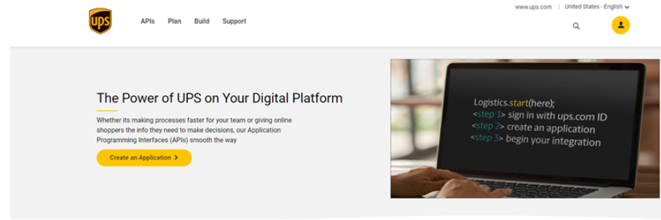

Go to Profile dropdown and choose Apps:

Then you will see below window, click on “Add Apps”.

## Integrate

On below page, select “I want to integrate UPS shipping capabilities to my business”. In the “Choose account” dropdown select an account if your user ID already has one associated, add an existing account, or open an account. Once the account is selected click Next.

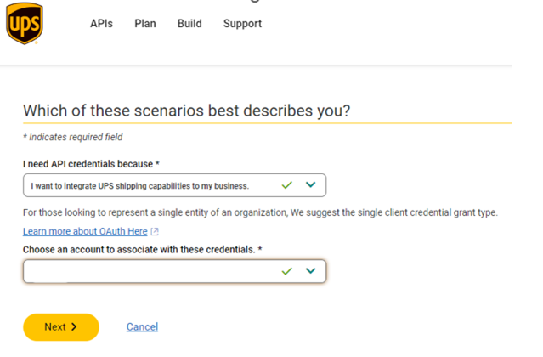

Add contact information. Fill out the required fields, then click Next.

## Add preferred API solutions

On the “Add App” page, give the app a name, click the + sign to add the desired Test or Production API products to your app. OAuth is required and is selected by default. (Don’t populate the callback URL)

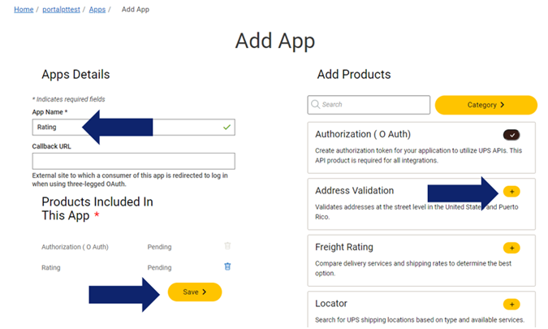

Add at least the following apps:

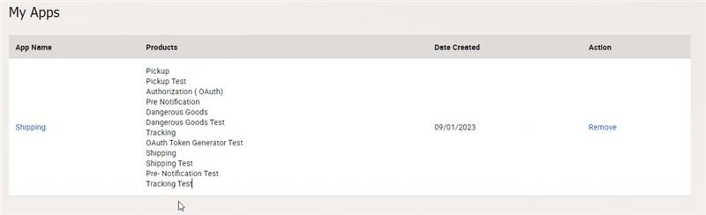

## Save API credentials

Click the “eye ball” icons to reveal the Client ID and Client Secret, copy and paste them somewhere for later use.

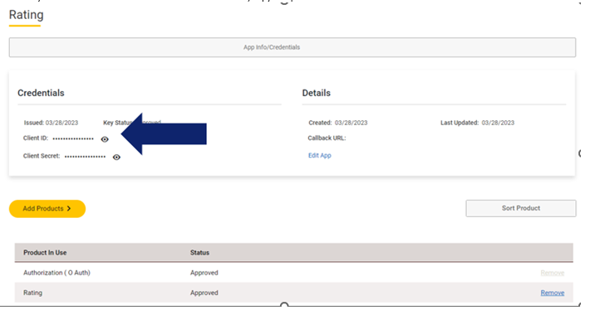

 All documentation for each API, you will find inside UPS developer portal.

